WHO WE ARE: A consumer-run program dedicated to improving quality oversight
of the public mental health system. CQT is located at the Mental
Health Association of Maryland, funded by the Mental Hygiene
Administration and based on a model pioneered by the Consumer
Satisfaction Team of Philadelphia.

WHAT WE DO: CQT makes regular site visits to public mental health facilities. Our
teams listen non-judgmentally to what consumers share during
voluntary, anonymous, qualitative interviews. We share this information
at every level of the system via Site Visit Reports and regular
Feedback Meetings.

HOW WE HELP:

The CQT process brings consumers’ ideas and needs to the people who have
the power to resolve problems and implement changes. Everyone in the
system gets information they need, in real time:

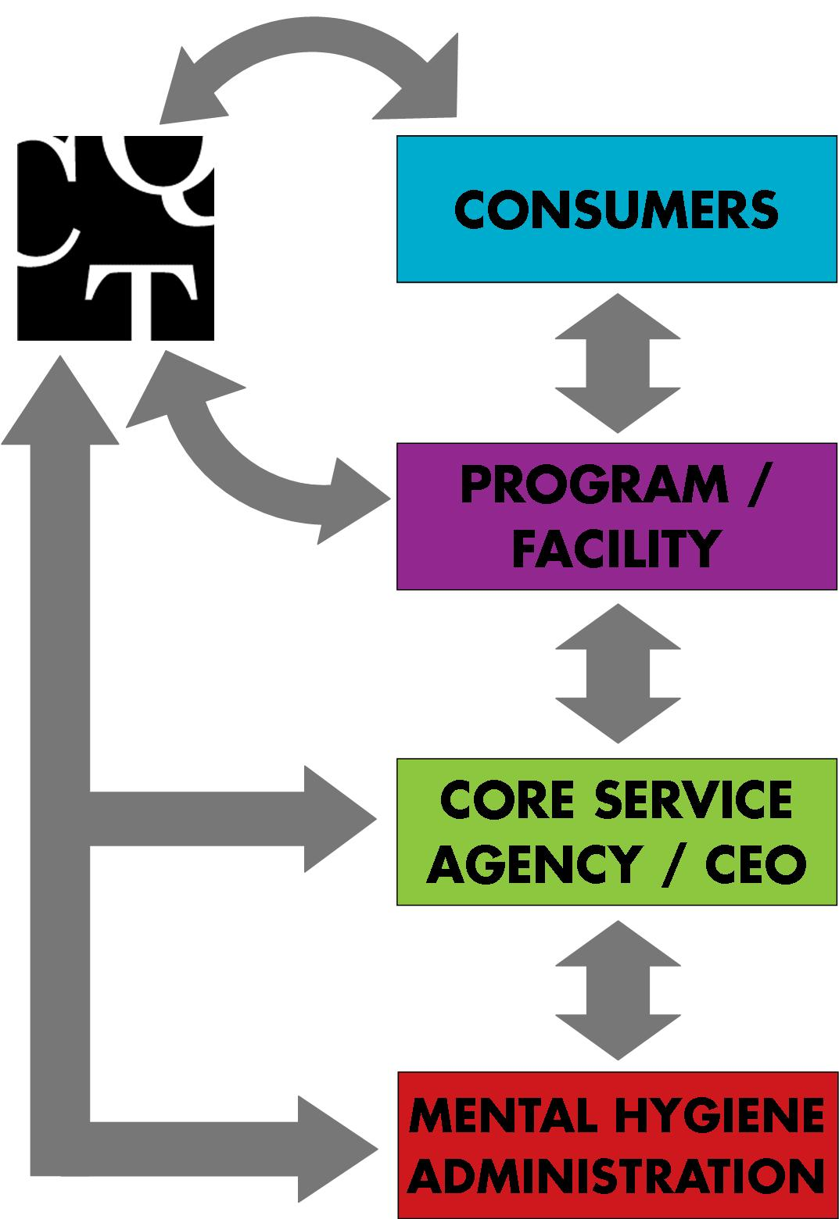
Consumers get requests or concerns brought to staff who can address them. Emergent issues are always reported immediately, and many issues are resolved in the same day.

Providers get positive feedback, suggestions for improvements and information about problems and barriers.

Core Services Agencies and CEOs see how programs are effectively helping consumers toward recovery and where they can grow.

Behavioral Health Administration gets feedback about how the public mental health system can better meet the expressed needs of consumers and programs.
BHA

FREQUENTLY ASKED QUESTIONS:

Does CQT do audits or investigations?

CQT does not conduct audits or investigations. The purpose of a CQT site visit is to collect unbiased, objective information about consumer’s satisfaction with the services they receive from a facility. This information is given to the director of the program and the CSA or CEO. Site Visit Reports are reviewed quarterly by the Behavioral Health Administration.

Does CQT verify comments or complaints?

CQT listens non-judgmentally to what consumers share about their lives, their needs, and their satisfaction with the services they are receiving. In some cases, consumers will discuss a particular problem, concern, or incident during an interview. CQT staff will ask follow-up questions to determine the nature and scope of the issue and, depending on the preferences of the consumer, will refer the consumer to an internal or external resource, alert program staff to the issue, and notify the CSA, CEO, or rights advisor.

Comments or complaints can be verified by the program, CSA or CEO. CQT may also report team member’s observations to program staff and alert staff to concerns or comments echoed by multiple consumers.

What agencies receive CQT Site Visit Reports?

CQT Site Visit Reports are sent to the director of the program or facility, and the CSA for that county or CEO of the inpatient facility. All Site Visit Reports are reviewed by BHA at the quarterly BHA Feedback Meetings.

…. In FY 2016, 1638 individuals
were interviewed through the CQT process.

HOW WE HELP

“I talked to CQT a few times when I was at [one program], and then when I moved up to [another program], CQT came there too. I needed housing. CQT talked to the program staff and to the
Core Service Agency.

The CSA got in touch with me and helped me get into Shelter + Care housing. I still have that housing today and it’s going very well. CQT has been very helpful… They’ve been there to listen and have been really supportive.”

In an inpatient facility, a consumer reported they were unable to have drinking water upstairs where the bedrooms are located. Medication caused them to be frequently thirsty, and they requested that water be available upstairs throughout the night. Unit staff shared that carrying cups of water upstairs posed a safety issue.

CQT reviewed this request with the senior management of the facility during the next Feedback Meeting, and they subsequently worked with the unit staff to create a safe water station upstairs
in the unit.

At a PRP, consumers told CQT about abuse by staff and their fear of retribution. Program staff repeatedly violated the confidentiality of the interviews, so CQT terminated the visit and immediately reported this information to the CSA.
Two days later, the program director reported corrective measures had been taken.

On the follow-up visit, consumers reported that the abusive staff had been replaced, the program curriculum had been improved, and the facility had been cleaned.

